**MUNICIPAL NEWS LETTER - AUGUST 2023**

**IMPORTANT INFORMATION**

We would like to inform you that the installation of our temporary offices (trailer) is now complete, and that they are located on the grounds of the municipal garage at 628 chemin de la Gare.

The removal of asbestos from the building at 601 chemin de la Gare is now complete.

If all goes well, demolition work at 601 chemin de la Gare will begin the week of August 28, 2023.

**COUNCIL MEETING**

The next Council meeting will be held on Monday, September 18, 2023, starting at 7:30 p.m. The mayor and council members will welcome you at the municipal garage, 628 chemin de la Gare. You may also attend by videoconference. We invite you to consult the public notice to be published on September 5 for full details. <https://ivry-sur-le-lac.qc.ca/nouvelles-et-avis-publics/>

**LABOR DAY**

**The Municipality's administrative offices will be closed on Monday, September 4, 2023, for Labour Day.**

**The entire team will be back on Tuesday, September 5, starting at 9 a.m**

**ADMINISTRATION – MUNICIPAL TAXES**

We would like to remind you that the last payment for your municipal taxes will be made no later than September 9, 2023, in accordance with by-law no. 2022-149 imposing taxes, tariffs and compensation on the territory of Ivry-sur-le-Lac for the fiscal year 2023.

Your payments must be received by the due dates to avoid late fees. In addition, the full balance of the account becomes due when a payment is not received by the due date.

It's also important to bear in mind that balances bear interest at a rate of 10% per annum, plus a 2% penalty calculated on unpaid balances.

**CONSTRUCTION WORKS**

**Project: Repair of Chemin Daoust and Chemin Lacasse - Update**

For civic address no. 501 and under, access must be made by via Montée Daoust.

For civic address no. 507 and over, access must be made by via chemin du Lac-de-la-Grise.

Paving work on chemin Manitou Sud will begin this fall.

Please consult INFO-TRAVAUX on our website.

NOTE: For your safety, we ask you not to use chemin Lacasse for your walks, as there is a lot of machinery and workers. Please choose another safe route so as not to endanger yourself or your pets.

**WORK ON 117 – IVRY-SUR-LE-LAC ET MONT-BLANC**

Work on Route 117 North will continue from July 24 to September 1, 2023, between Chemin de la Gare and Chemin du Lac-Nantel Sud in Mont-Blanc. This work will result in the closure of one lane in two, between 6 a.m. and 8 p.m. (1 p.m. on Fridays) and the reduced lane width will be 3.5 metres.

The duration of work and obstacles may be modified due to operational constraints or weather conditions. See Quebec 511 for more information about this barrier. For the safety of road users, compliance with the signs in place is essential. and the reduced lane width will be 3.5 metres.



**LIMITED BEARING CAPACITY OF THE DUPÉRÉ BRIDGE**

DATE : Open-ended

ROAD : Chemin du Lac-de-la-Grise

MUNICIPALITY : Ivry-sur-le-Lac

LOCATION : Dupéré bridge, between Chemin A.-Bicari and Chemin du Bord-de-l'Eau

Following an inspection, the load-bearing capacity of the structure must be limited to 15 tonnes for all types of vehicles.

The Ministry thanks users for their invaluable cooperation. This new load limit will protect certain structural elements from premature deterioration.

INFORMATION: Samantha Saroufim, Communications Advisor

Ministère des Transports et de la Mobilité durable

Direction générale des Laurentides-Lanaudière

Media line: 1 866 341-5724

samantha.saroufim@transports.gouv.qc.ca

**MUNICIPAL BOAT WASHING STATION AND LANDING**

**notice of closure of the municipal landing – end of season**

The boating season is already drawing to a close. The car wash and municipal landing will close for the season on Tuesday, October 31 at 5:00 p.m.! We ask you to plan your outing no later than October 31, 2023.

From September 2 to October 31, we will be open 7 days from 8:00 am to 5:00 pm. After this date, you must make an appointment at least 24 hours in advance by calling 819 321-2332 ext. 3704.

**WE REMIND YOU OF THE IMPORTANCE OF WASHING YOUR TRAILERS BEFORE TAKING YOUR BOATS OUT OF THE WATER.**

Thank you for your cooperation!

**ENVIRONMENT – MULCH DISTRIBUTION**

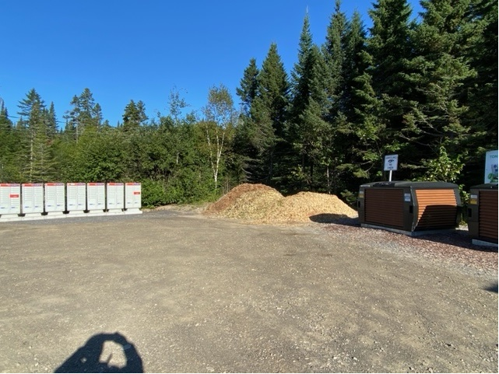

We remind you that we always have mulch available at the municipal garage. It's a mixture of wood chips, and the last trip we're expecting will be cedar. Do your flower beds need mulch? You can obtain it free of charge from the municipal garage at 628 chemin de la Gare.

Come one, come all.

**ENVIRONMENT – SEPTIC TANK EMPTYING**

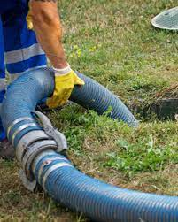**CITIZEN'S OBLIGATION TO PROVIDE PROOF OF EMPTYING**

According to article 4 of by-law 2009-131, when you have your septic system emptied, it is your responsibility to send proof of completion of the work to the municipality by October 15 of each year in which emptying is required by the by-law.

Although various service providers offer to send proof to the municipality, we never receive them all. It's best to send it to us yourself by e-mail (admin@ivry-sur-le-lac.qc.ca), where we'll confirm receipt and update your file.

An annual maintenance contract is required for certain septic systems (Ecoflo, Bionest, Enviro-Septic, etc.). The same applies to annual maintenance. Send us proof to update your file. We accept a copy of the maintenance contract. Under section 4 of By-law 2009-131, when you have your septic system pumped out, it is your responsibility to submit proof of completion of the work to the municipality no later than October 15 of each year in which pumping is required by the by-law.

**MRC DES LAURENTIDES – ACTION AND SOCIAL DEVELOPMENT PLAN**

After several months of consultations and regular meetings with community partners, the MRC des Laurentides is proud to unveil its 2022-2027 social development action plan.

An action plan with five priorities

The ambitious objectives set by the members of the social development committee are divided into five areas, the first of which is the pursuit of partnerships with organizations, the MRC and municipalities. The other priorities are: food security, community housing, public transportation and reduced mobility, and community support. A detailed version of the action plan is available at

<https://mrclaurentides.qc.ca/documentation/plan-daction-en-developpement-social-2022-2027/>

**MRC DES LAURENTIDES – ECOCENTRES – TEMPORARY HALT TO HOUSEHOLD HAZARDOUS WASTE (HHW) COLLECTION**

**We would like to remind you that it is forbidden to dispose of any hazardous household waste in containers or bins.** The MRC des Laurentides wishes to inform the public that the collection of hazardous household waste (HHW) at ecocentres is suspended until further notice.

HHW are substances that require safe storage, both for the health of individuals and for the environment. However, the increased traffic at ecocentres is such that HHW containers are overflowing, and the regular HHW collection service is no longer sufficient to make room for them.

The following substances are considered HHW. We can easily recognize them by the pictograms on the containers (corrosive, flammable, toxic or explosive):

* Paints, varnishes and solvents;
* Used motor oil;
* Aerosols;
* Oxidizers;
* Propane tanks;
* Pesticides and fertilizers;
* Ink cartridges;
* Cleaning products;
* Compact fluorescent bulbs;
* Thermometers;
* Fire extinguishers (domestic only);
* Alkaline and rechargeable batteries.

The MRC des Laurentides is therefore asking users to temporarily keep their HHW at home, until collection services have emptied the current storage containers, which could take a few weeks. It also reminds users not to dispose of HHW in the garbage bin, at the curb or in reuse organizations such as thrift stores, and thanks the public for its usual cooperation.

**FIRE SAFETY – SWEEPING YOUR CHIMNEY**

More than 1,200 chimney fires occur on average every year in Quebec. They represent a potential source of building fires that could cause major material and human losses. That's why it's important to entrust the installation of a new heating appliance to a professional in the field. Regular maintenance of the appliance and its components is also essential.

Chimney sweeping helps prevent fires. It also helps :

- Prevent carbon monoxide poisoning by allowing smoke and toxic or noxious gases to escape more easily;

* Remove soot and flammable deposits (creosote) that have accumulated in the chimney;
* optimize the efficiency of the heating appliance and save fuel;
* The chimney sweep's job is to detect any breakage or deterioration of the heating system and its components.

A professional chimney sweep should have the knowledge and expertise to detect installation problems. He or she should be able to advise you on the proper use and maintenance of each appliance, and should have the equipment, tools and protective clothing needed to carry out a safe and effective sweep. The Régie du bâtiment du Québec's register of licensees can be consulted to find or verify certain information about a contractor.

You can also get information from various heating industry associations.

**What is creosote?**

Creosote is a deposit formed by smoke resulting from incomplete combustion or poor combustion of wood. It clings to the chimney walls and is highly flammable. Only a professional chimney sweep can effectively remove it.

How can creosote be prevented?

It's impossible to completely prevent creosote formation when burning wood. However, it is possible to limit its formation by adopting these good habits:

* Start your fire with blazing flames (high heat);
* Burn dry wood;
* Use small logs. They will burn cleaner, forming less creosote.

Source: Régie Incendie des monts https://ridm.quebec/prevention

**FADOQ – RÉGION DES LAURENTIDES**

**OPEN HOUSE - AUTUMN 2023**

**FADOQ - RÉGION DES LAURENTIDES IS PROUD TO INVITE YOU TO ITS VERY FIRST ANNUAL OPEN HOUSE!**

La FADOQ - Région des Laurentides is a non-profit organization offering a variety of services for people aged 50 and over.

We invite you to discover our fall program of cultural, physical, intellectual, computer and educational activities.

The open house will be an opportunity to network with the office team and workshop leaders. All in a warm and festive atmosphere.

Come and join in the festivities - a host of activities await you!

More details on our website:

[www.fadoq.ca/laurentides/activites/evenements/journee-portes-ouvertes-automne-2023](http://www.fadoq.ca/laurentides/activites/evenements/journee-portes-ouvertes-automne-2023)

**LEISURE, CULTURAL AND ARTISTIC ACTIVITIES - REMINDER**

In our next monthly newsletters, we'd like to publish activities (shows, vernissage, crafts, hiking) - in fact, anything and everything related to not-to-be-missed events in our community! Is there a show near you that you'd like us to attend? We're here for you! Send us your articles (200 words maximum) with one or two accompanying photos, and we'll publish them! Take out your pencils and camera, and send them with the subject line: Monthly Newsletter to the following address: [adjointe@ivry-sur-le-lac.qc.ca](mailto:adjointe@ivry-sur-le-lac.qc.ca)

Thank you for your confidence and know that it's always a real pleasure to represent you!



Le maire,

**André Ibghy**

Municipalité d’Ivry-sur-le-Lac

Tél. (819) 321-2332

[maire@ivry-sur-le-lac.qc.ca](mailto:maire@ivry-sur-le-lac.qc.ca)